**WICDS PROJECT**

**Mentor -** Saloni Jaitly

**Mentee -**  Bhuvana Venigalla

**NEURAL NETWORK ON HEART DISEASES**

Data can be processed and many models can be built using various algorithms provided by Machine Learning. Models are selected based on the requirement of the client or the user. Maintaining accuracy is a very crucial step while building a model. Various steps lead to a decrease in accuracy which must be overcome for better results.

A neural network is a collection of algorithms, through a mechanism that mimics the way the human brain works, that aims to identify underlying relationships in a set of data. A neural network, a computer machine that functions in a way influenced by the brain's actual neural network. These may adapt to evolving inputs, so the network produces the best possible outcome without the output parameters having to be revamped.

Given a dataset containing various inputs regarding a person's health status and whether or not the person is having heart disease or not. The best suitable technique to build a model using this data is to construct a neural network.

Neural Network on heart diseases, this project includes data importing where a file with dat extension is imported using pandas,

**Importing the dataset**

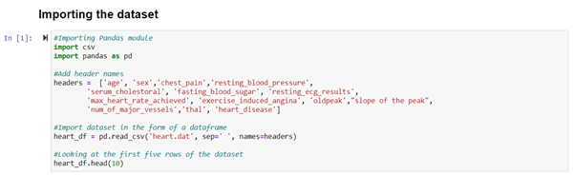

**Data Cleaning**

data cleaning includes removing any null values if found, creating new columns as per requirements, reshaping the dataset, swapping values, etc.

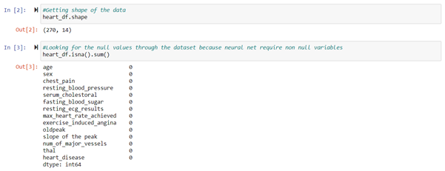

**Data Splitting**

data splitting is an important part where given data is split into training, and testing using sklearn.train_test_split module and a random state as assigned to it. The data will be assigned to 4 variables, i.e x_test, y_test, x_train and y_train.

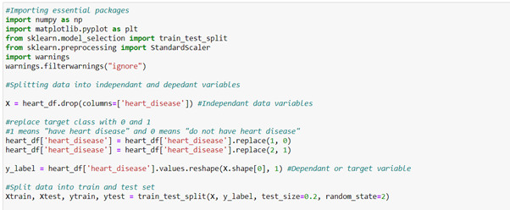

**Building a Neural Network**

A neural network consists of the following operations:

* Initialization
* Defining activation functions
* Forward propagation
* Backward propagation
* Model fitting
* Loss calculation
* Prediction and Accuracy
* ***Activation Function:*** These are mathematical equations that determine the output of a neural network. These attached to each neuron in the network, and determines whether it should be activated or not.
  + The activation functions used in this model are
    - Relu
    - Sigmoid
* ***Forward propagation:*** Input data is “forward propagated” through the network layer by layer to the final layer which outputs a prediction.

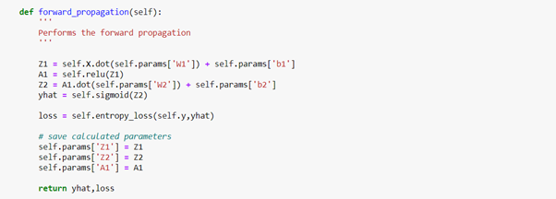

* ***Backward Propagation:*** Back-propagation is just a way of propagating the total loss back into the neural network to know how much of the loss every node is responsible for, and subsequently updating the weights in such a way that minimizes the loss by giving the nodes with higher error rates lower weights and vice versa.

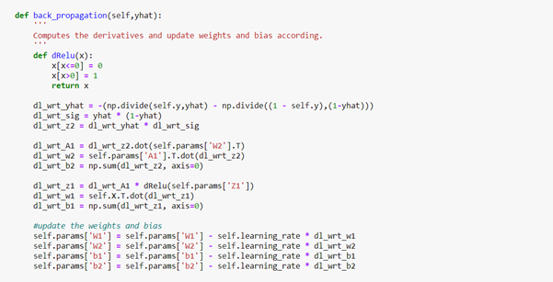

* ***Accuracy:*** Accuracy is calculated by comparing the percentage of predicted values to the actual values that matched together.

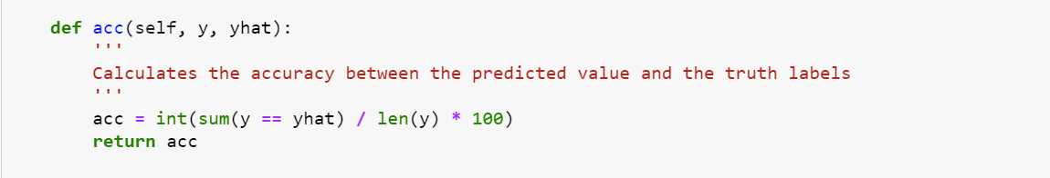

* ***Loss calculation:*** Loss is calculated to increase the accuracy. The main aim of a loss function is to make the value converge to correctness. Every time loss is calculated, the model parameters get updated accordingly.

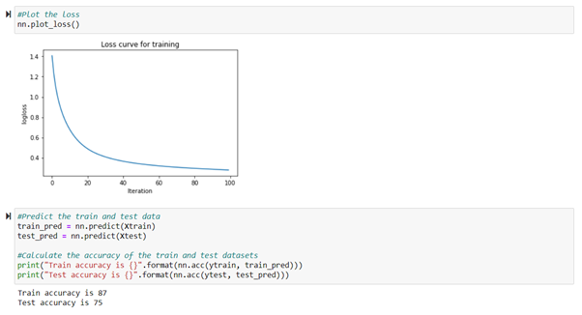

* ***Prediction:*** The prediction of training data over testing data resulted in 87 percent of training accuracy and 75 percent of testing accuracy.